Ritika Kumari- A20414073

CSP554—Big Data Technologies

Question 1:
6) Submit a copy of this modified program and a screen shot of the results of the program’s execution as the output of your assignment.
Program Executed:
from mrjob.job import MRJob
import re
WORD_RE = re.compile(r"[\w']+")
class MRWordCount(MRJob):
def mapper(self, _, line):
for word in WORD_RE.findall(line):
allowed = 'abcdefhgijklmn'
if any(word.startswith(x) for x in allowed):
yield 'a_to_n', 1
else:
yield 'others', 1

def combiner(self, word, counts):
yield word, sum(counts)

def reducer(self, word, counts):
yield word, sum(counts)
if __name__ == '__main__':
MRWordCount.run()
Screeshots of command executed:
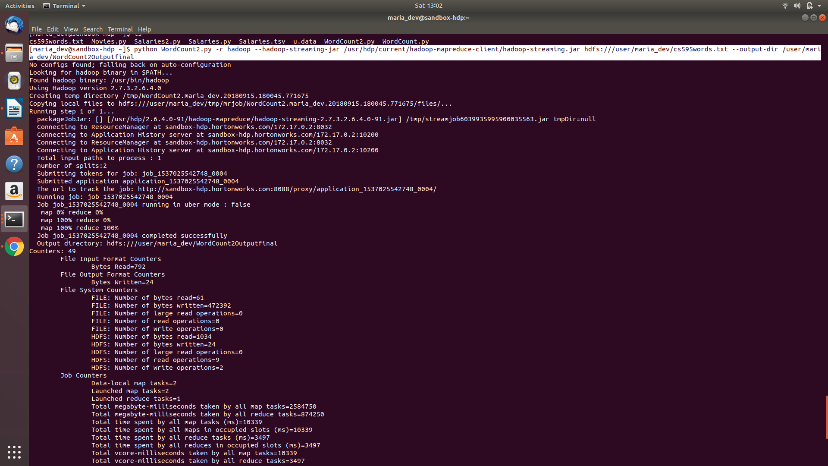
Screeshots of output:
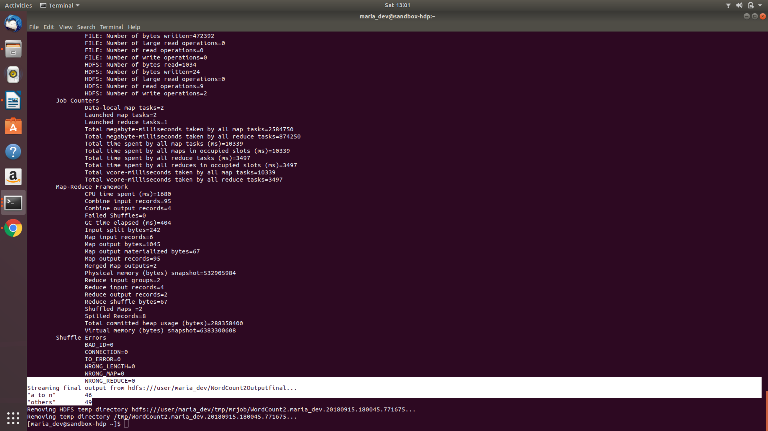
Question 2:
10) (5 points) Submit a copy of this modified program and a screen shot of the results of the program’s execution as the output of your assignment.
Program Executed:
from mrjob.job import MRJob
class MRSalaries(MRJob):
def mapper(self, _, line):
(name,jobTitle,agencyID,agency,hireDate,annualSalary,grossPay) = line.split('\t')
salary = float(annualSalary)
if(salary >= 100000):
yield 'High', 1
elif(salary >= 50000 and salary < 100000):
yield 'Medium', 1
else:
yield 'Low', 1

def combiner(self, salrange, counts):
yield salrange, sum(counts)
def reducer(self, salrange, counts):
yield salrange, sum(counts)

if __name__ == '__main__':
MRSalaries.run()

Screenshots of command executed:
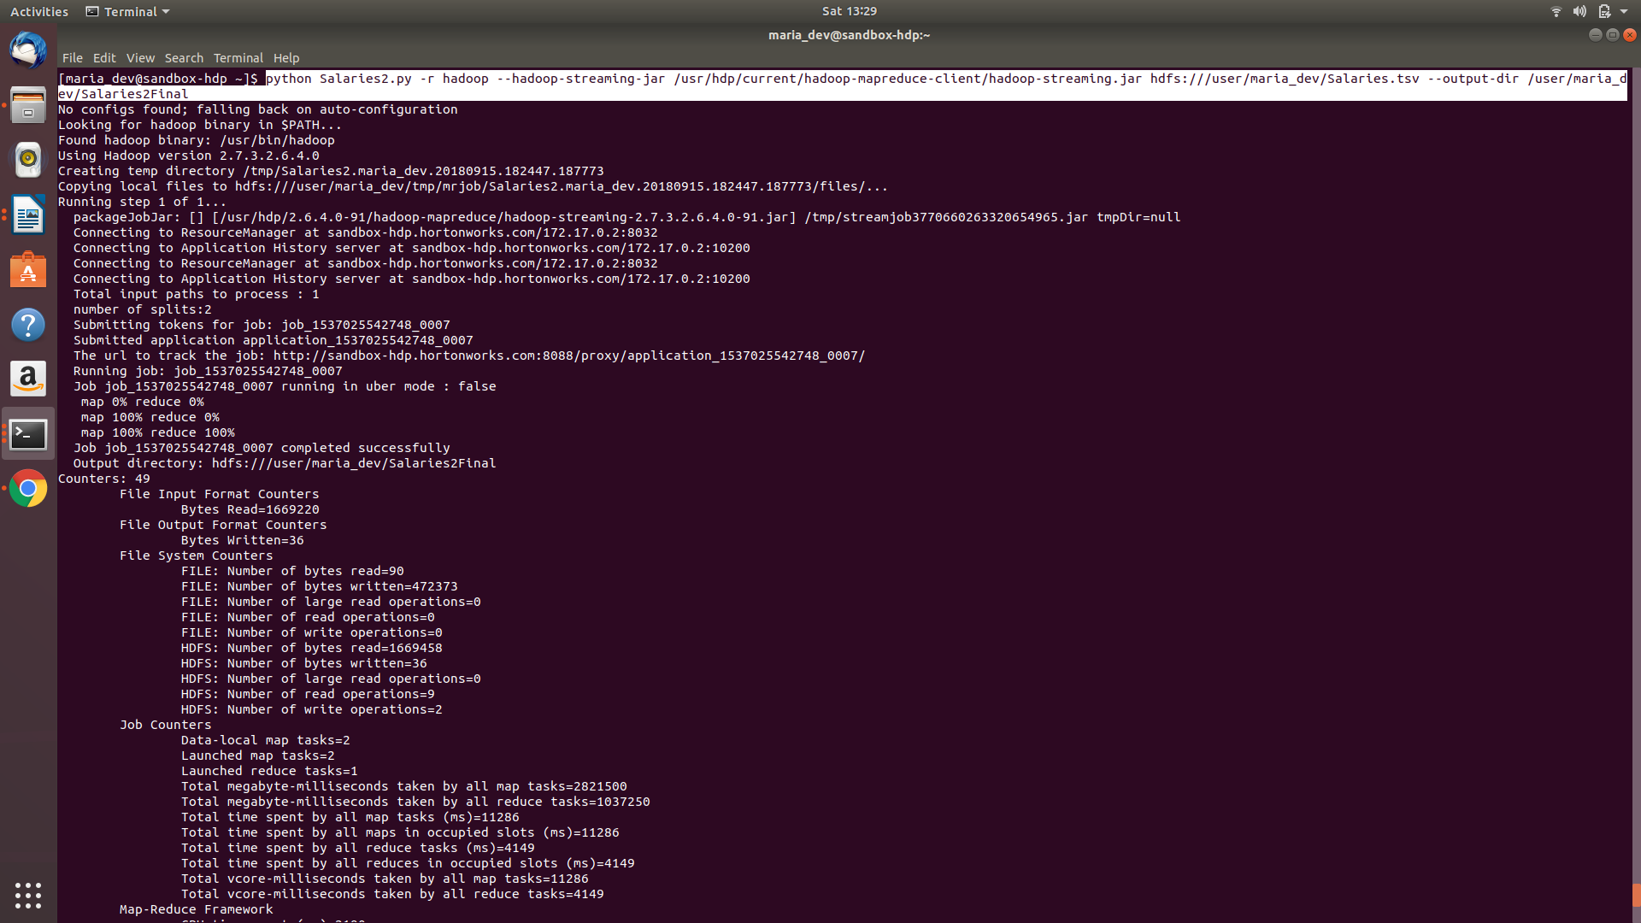
Screenshots of Output:
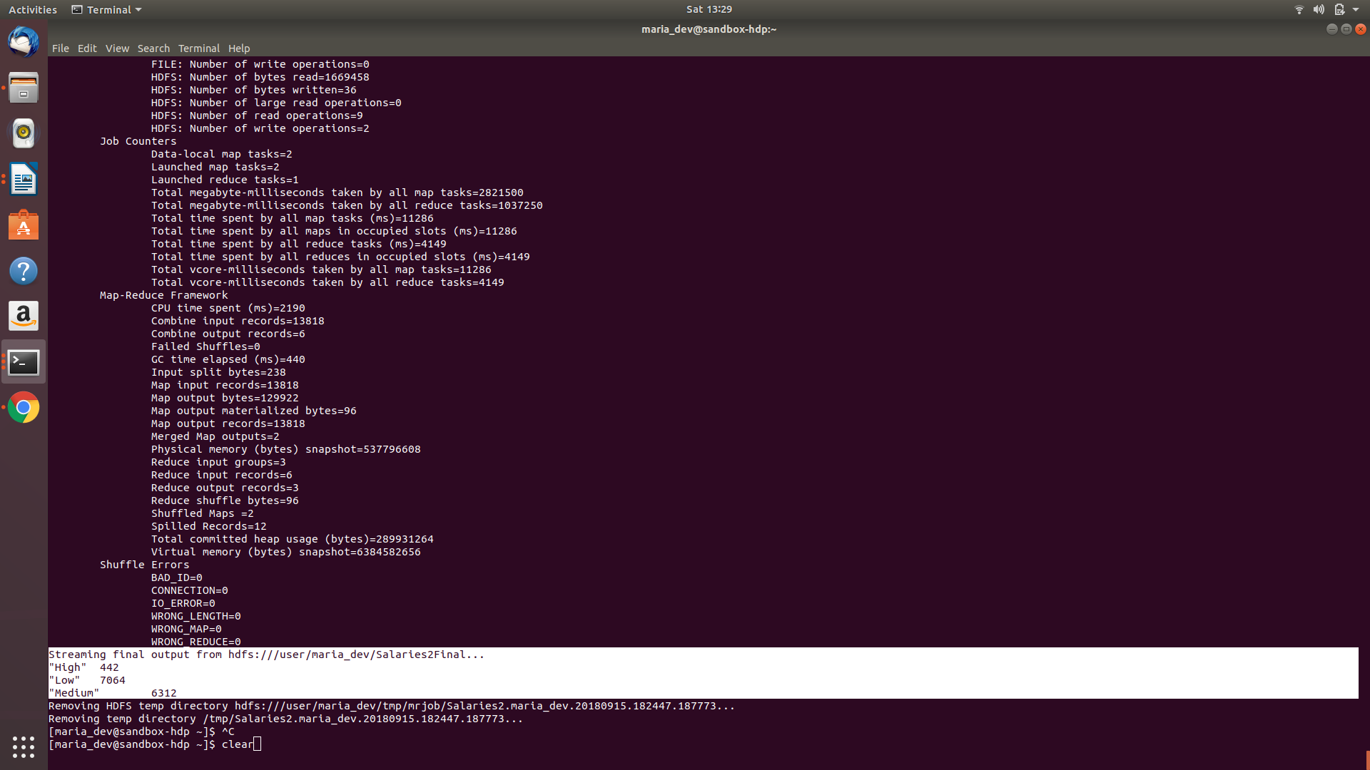

Question 3:
Submit a copy of this program and a screen shot of the results of the program’s execution (only 10 lines or so of the result) as the output of your assignment.
Program:
from mrjob.job import MRJob
class MRSalaries(MRJob):
def mapper(self, _, line):
(USER, MOVIE, RATING, TIMESTAMP) = line.split(',')
yield USER, 1
def combiner(self, USER, counts):
yield USER, sum(counts)

def reducer(self, USER, counts):
yield USER, sum(counts)
if __name__ == '__main__':
MRSalaries.run()

Screenshots of command executed:
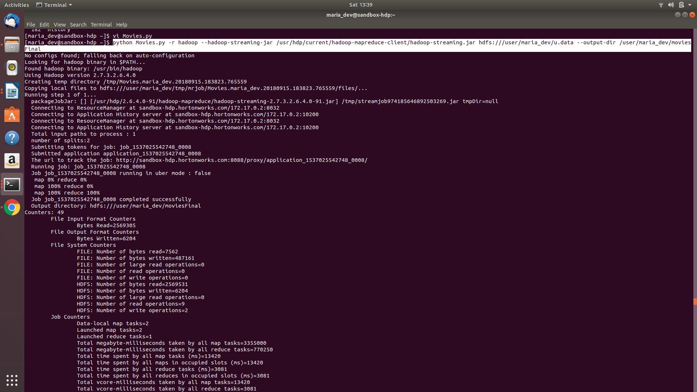
Screenshots of Output:
